Please log on to **wiprolimited.procurement.ariba.com**

* Always click **HOME** and select **Create** 🡪 **Requisition**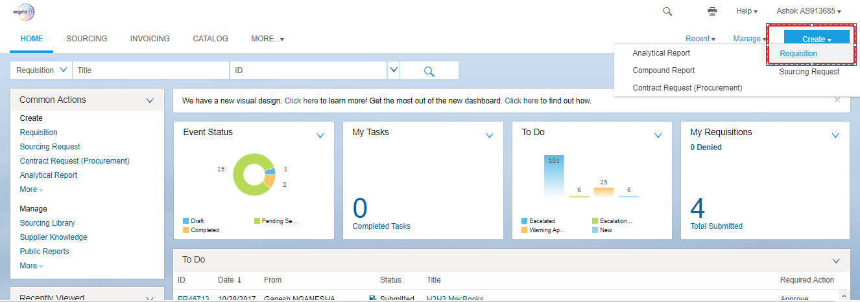
* Click Add Non-Catalog Item 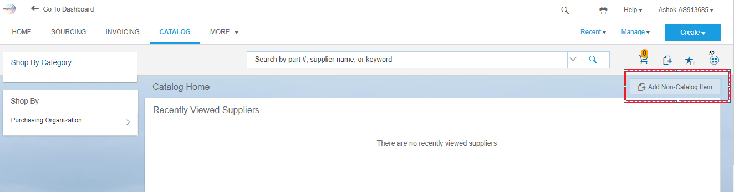
* You are able to see below Screen

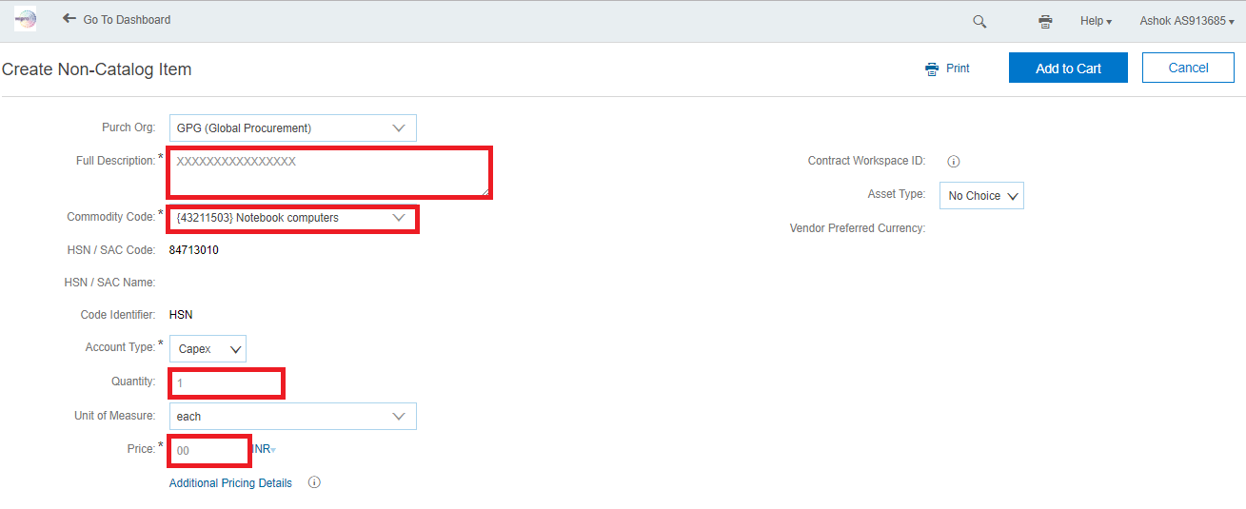

* Please provide details of requirement in Full Description field.
* Please select relevant Commodity code on the below Attached file.



* Select Required Quantity
* Provide approximate price.
* Click Add to Cart and select Proceed to check out.

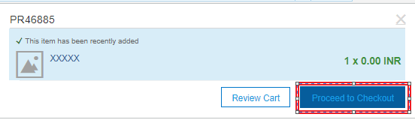

**Header Part**

Step 1: Please enter Title that should related to the request.

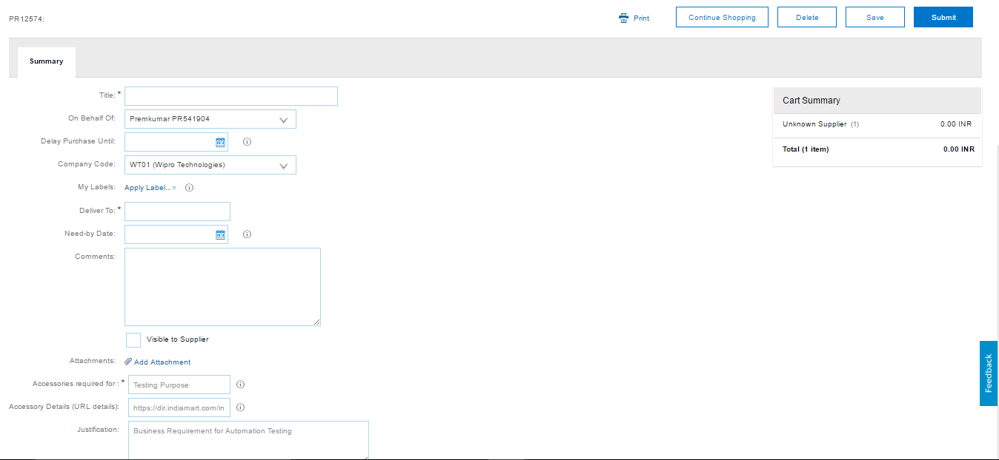

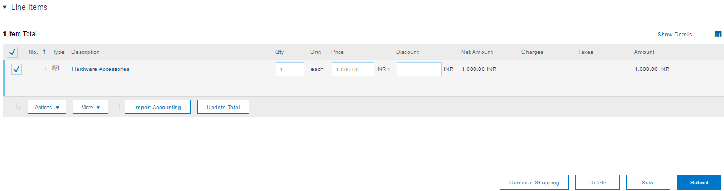

Step 2: Deliver To – Tower and Specific delivery location details if any.

Step 3: Please enter Comments if any

Step 4: Always Attachment Supporting documents which will help us faster processing of request.

Step 5: Before submitting the PR; Please always go to **Actions 🡪 Edit Details**

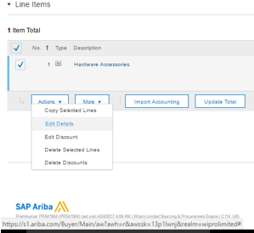

Step 6: You could see most of the details filled at earlier stages, scroll down to

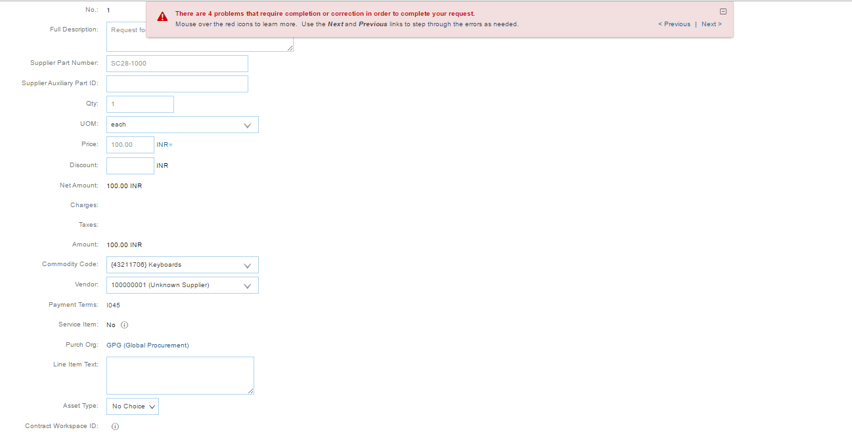

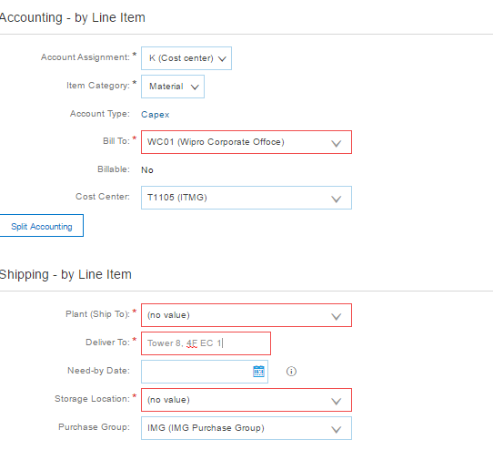

Step 7: by default, Account Assignment will be K (Cost Center), Please Choose P (Project) if it needs to be create under Project.

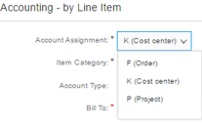

Step 8: Please fill Bill To details by clicking the down Arrow (\/) and Search More, always storage Location must be Bill To.

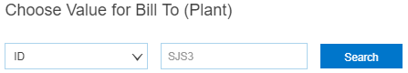



Step 9: In **Shipping by Line Item** section – Please fill the Storage location same as Bill To.

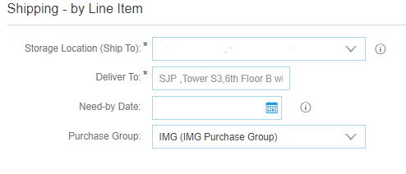

By clicking the down Arrow (\/) and Search More, You can see the only Bill To location selected above.

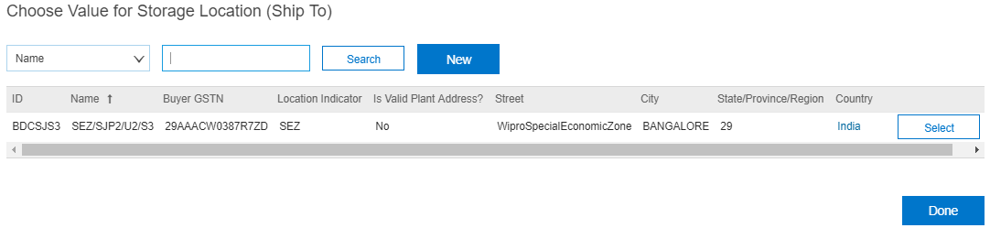

Step 10: Select the Corresponding Storage Location details based same as Bill To



Select the Required Storage Location, now you could see the below filled Shipping details

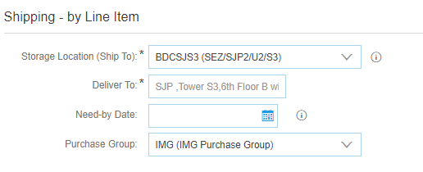

Click Save Button at the Bottom and it will take you to Line Level Page.



Try Submitting the PR now.



You will get the below window, once the Requisition is submitted.

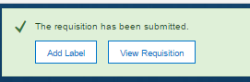

You can view your Requisition by clicking on it.

* Please raise the helpline call for any changes in the **approval workflow / Related Ariba issues**.

**Helpline.wipro.com >> Source to Pay Tile on the right hand side of the helpline home page >> Under “data issues” category**

**For approving the Ariba request.**

* Please log on to **wiprolimited.procurement.ariba.com** and approver will find the request under “My To Do” under ‘Manage’ Tab list to approve